**2022503003**

**Activity Diagram:** Focuses on the *detailed flow of actions* and *decision-making* in a system, representing control flows and transitions.

**Swimlane Diagram**: Highlights *which actors are responsible for specific actions*, grouping activities into roles, and providing a more straightforward representation of actor interactions.

**Activity diagram:**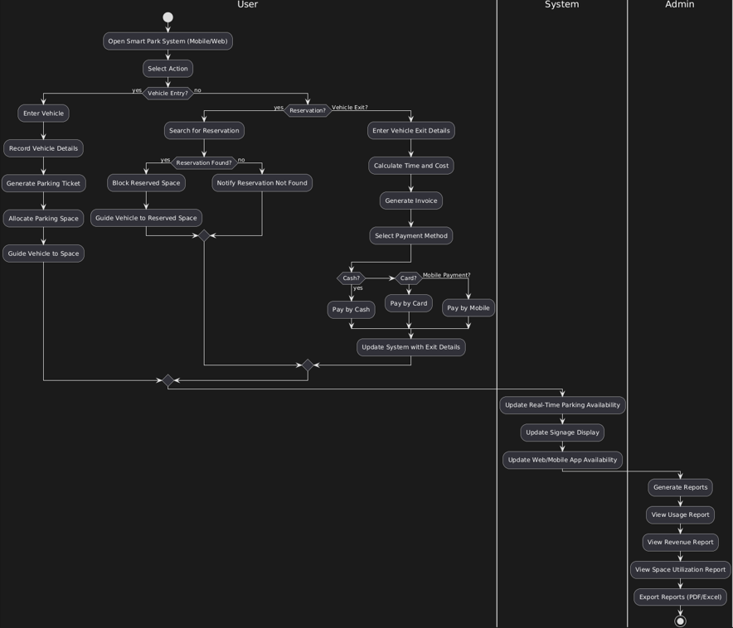

**Simlane diagram:**

